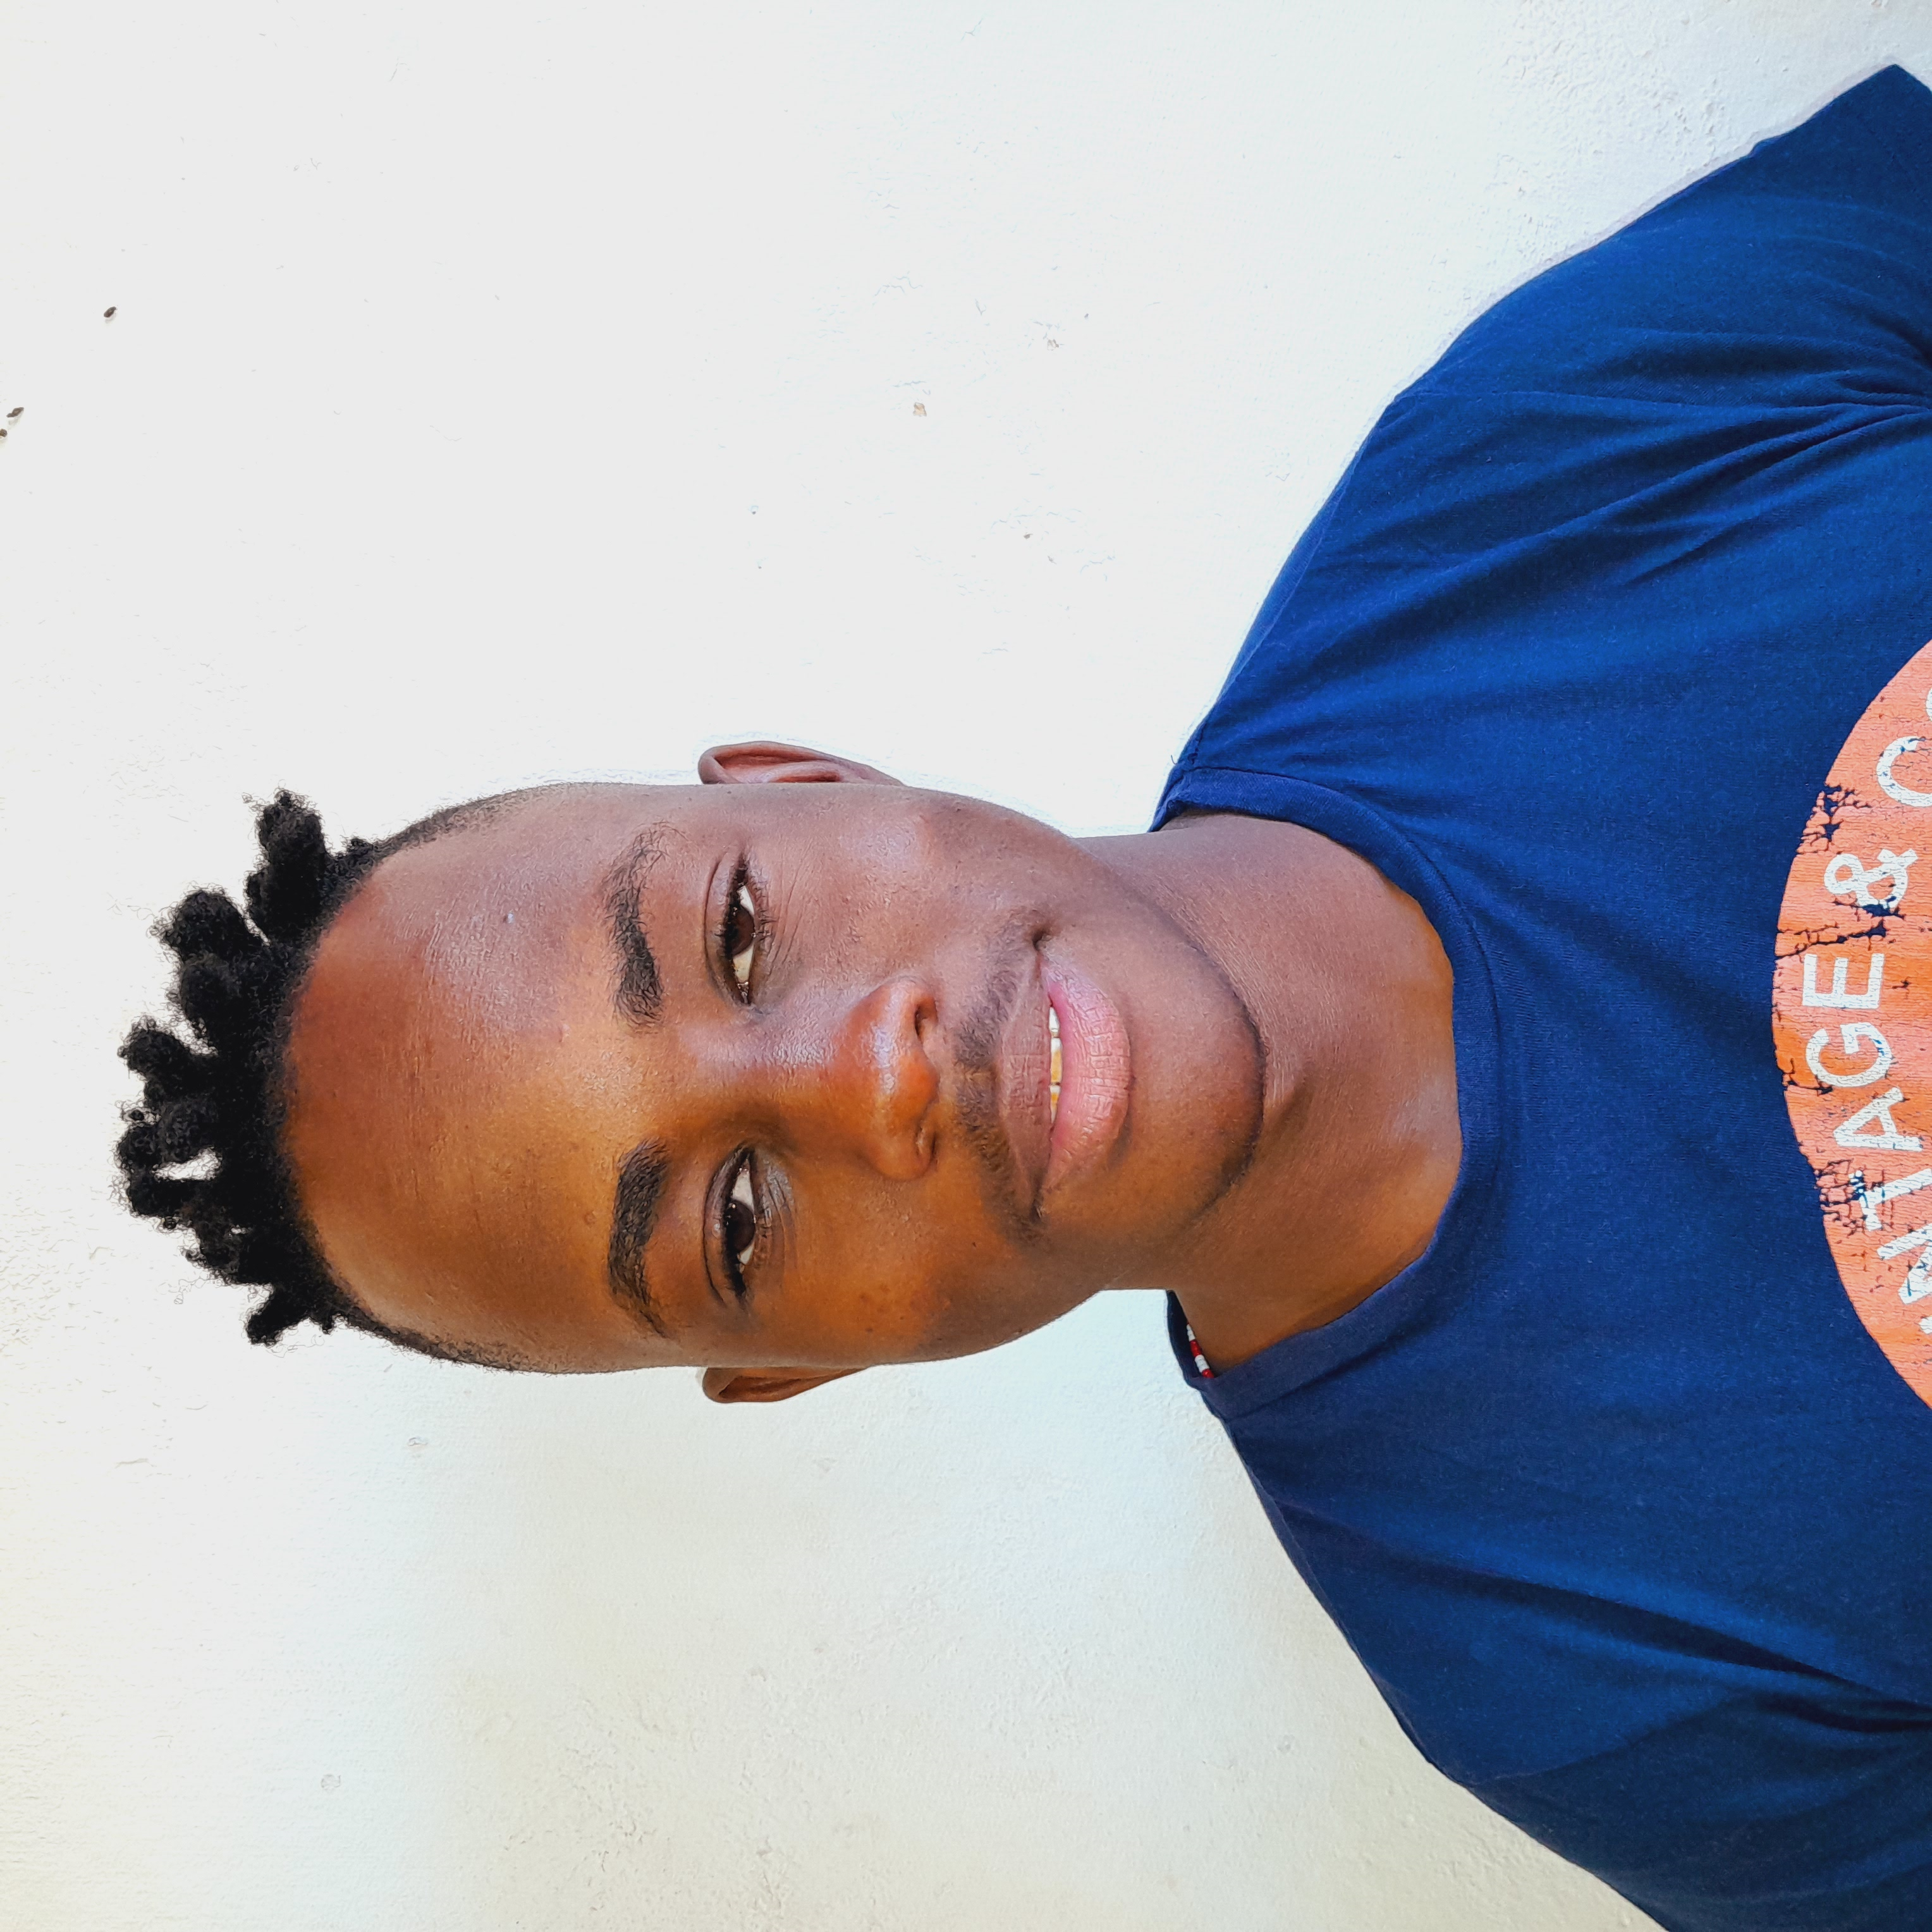

CANDIDATE

JIM BHOMBELA LEBESE

RESUME

# About me

Motivated and passionate in whatever I choose to do, I have strong interpersonal and communication skills and know how to handle and deal with different kinds of people and circumstances. Equal effective working independently and cooperation with others.

# Achievements & Key Projects

April 2022-May 2022

Facilitating Secondary learners around Anglo American Mogalakwena with the making Lego vehicles that are powered by hydrogen as a fuel.

# Work Experience

Anglo American

IT Technician Assistant

February 2022 – February 2023

Managing IT devices designed to enhanced teaching and learning

CapaCiTi

System Developer

March 2023- Present

Learning programming language and learning web development technologies. Problem solving skills and the ability to troubleshoot issues that arise during development.

# References

Claire Almond

[Claire.Almond@angloamerican.com](mailto:Claire.Almond@angloamerican.com)

060 972 1716

Kefiloe Mphye

[kefiloe.mphye@capaciti.org.za](mailto:kefiloe.mphye@capaciti.org.za)

081 334 8416

# Personal Details

**Date of Birth:**

21 May 2004

**Residential Area:**

24 Biccard Street Braamlofts

Campus Africa

Johannesburg

2001

**Languages:**

English

Sepedi

XiTsonga

# Education

2021 – Matanta Secondary School

National Senior Certificate

2022- Reach Summit Global

IT Technical Support NQF Level 4

# Online Presence

https://www.linkedin.com/in/jim-bhombela-lebese-3875a6275

# Key **Skills**

IT Technician

Presenting Information

Online Communication and Collaboration

# Interests & Hobbies

Reading

Traveling

Internet of Things

Exercise